Science grade 3 Name ______________

Ch 1 Study Guide for Ch 1 TEST Section _____________

Study the following statements for the chapter test.

1. A plant that has fibrous roots has ***long stringy roots****.*

Here is an example of a fibrous root.

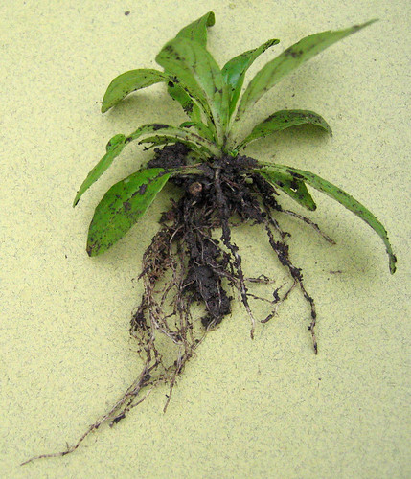

[This Photo](https://www.flickr.com/photos/71183136@N08/7093190407/) by Unknown Author is licensed under [CC BY-SA-NC](https://creativecommons.org/licenses/by-nc-sa/3.0/)

1. To survive and grow, a plant needs air, water and ***sunlight.***
2. We eat the stems of a ***celery stick.***
3. Tubes that carry food through a plant’s leaves are its ***veins.***
4. Everything that surrounds and affects a plant is called its ***environment.***
5. The smallest and most basic unit is a ***cell.***
6. Substances that plants need to grow and survive are called ***nutrients.***

Numbers 8 – 10 are filling in the parts of a plant.

Correctly label the ***root, leaves and stem*** only***.***

